Exploring Tentative Working Circles

- Enter APFDGIS.com in your Web Browser Address bar. Please click Tentative Working Circles link/ button for required task

Type apfdgis.com on Address bar of Browser

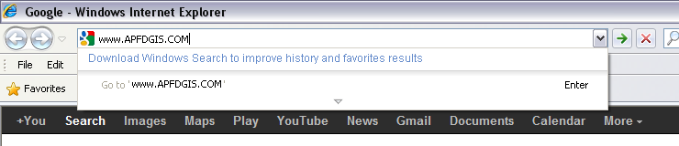

ENTER

Click on right side link “Tentative Working Circle”

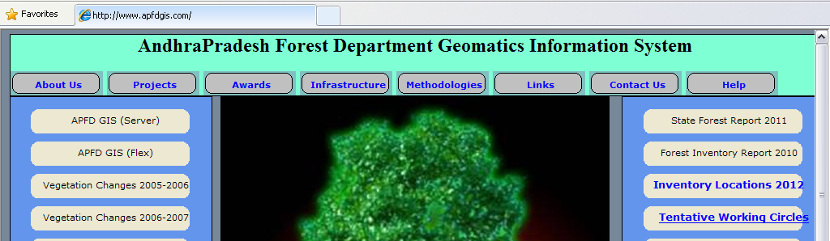

CLICK
Working Circles window
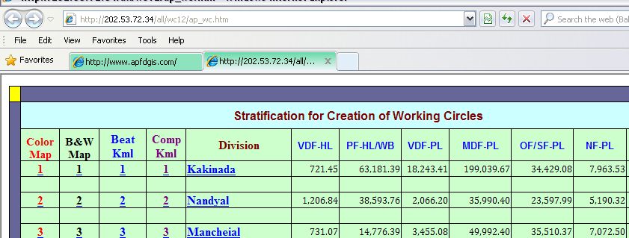

- Go to Required Division number under column name use right mouse button click select option Save Target as/ Save Link as.
Then download the file in your local computer Directory.

Click right mouse button on Link
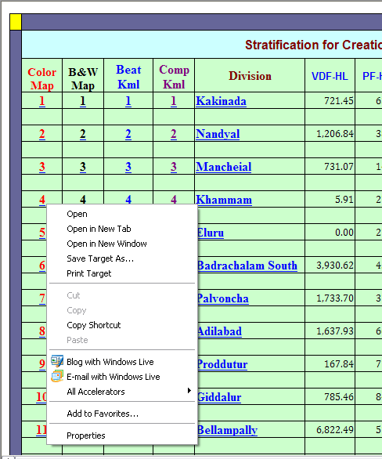

Save in your Computer

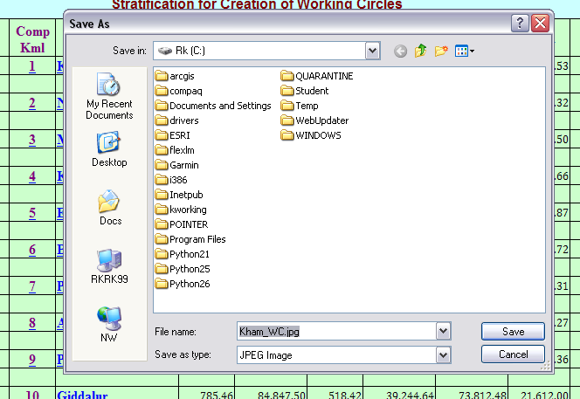

Local File Name

Column Names: Color Map, B&W Map, Beat KML, Comp Kml

To Download GOOGLE EARTH

For Kml files we need GOOGLE Earth to open

- From Working Circles Window download googleearthsetup.exe file From “GOOGLE EARTH “link to your Computer.

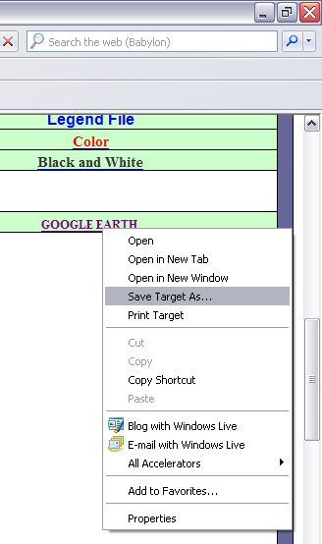

- From your Local computer click the downloaded File. (googleearthsetup.exe)

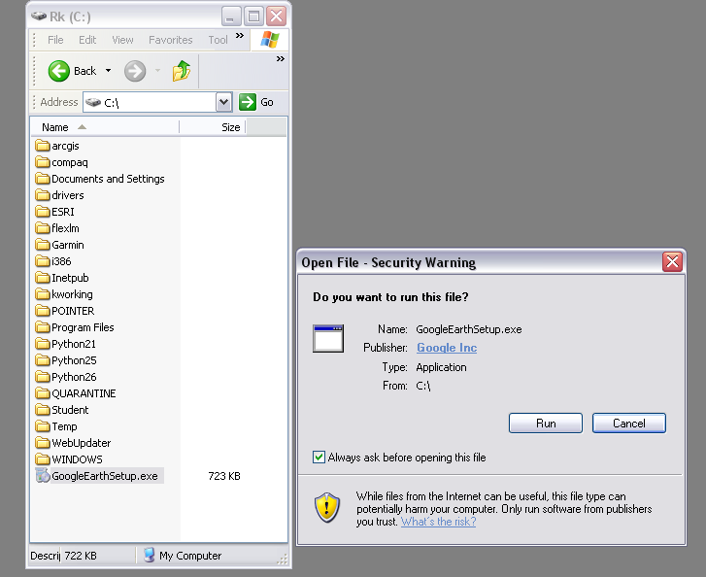

Click Run Button to install.

Exploring APFD GIS.COM

Enter APFDGIS.com in your Web Browser Address bar. Please click in required link/ button for required task

- APFDGIS(Server): Gives the view and information about GIS layers like Division, Range, Beat, VSS, Plantations, Inventory locations, Roads, Streams, Villages, Mandals, Blocks Vegetation Change Locations, FSI Points, Fire.. etc. we can overlay the themes, we can do some tasks like Calculation of Area, Buffer, Print Distance etc. This is developed using .Net Programming with ArcGIS Server Platform.

- APFDGIS(Flex): Gives the view and information about GIS layers like Division, Range, Beat, VSS, Plantations, Inventory locations, Roads, Streams, Mandals, Villages, Blocks Vegetation Change Locations, Fire.. etc.. We can overlay backgrounds like Streets Maps, Topo Images and Ariel Images. This is developed using Flex Programming.

- Vegetation Changes 2005 – 2006: Gives information about Vegetation Cover Change Locations of Divisions during the year 2005-2006. We can download required division information in the form of Excel sheets.

- Vegetation Changes 2006 – 2007: Gives information about Vegetation Cover Change Locations of Divisions during the year 2006 -2007. We can download required division information in the form of Excel sheets.

- Vegetation Changes 2007 – 2008: Gives information about Vegetation Cover Change Locations of Divisions during the year 2007 - 2008. We can download required division information in the form of Excel sheets.

- Vegetation Changes 2008 – 2009: Gives information about Vegetation Cover Change Locations of Divisions during the year 2008- 2009. We can download required division information in the form of Excel sheets.

- Vegetation Changes 2009 – 2010: Gives information about Vegetation Cover Change Locations of Divisions during the year 2009 -2010. We can download required division information in the form of Excel sheets.

- Changes 2010 – 2011: It Gives information about Vegetation Cover Change Information of Divisions during the year 2010 -2011. Total Division wise data is available according to Divisions number, we can download the data of each division according to our requirement.

- Change Statistics: It gives Vegetation Cover Change Information about Positive Locations, Negative Locations and Total Area in Hectares.

- Vegetation Changes Info: It gives information about Division Wise Vegetation Cover Change Information according to Positive change, Negative change according to Class in which it belongs to. Positive Location, Negative Location, Total Area in Hectares, and also Positive Area in Hectares and also Negative Area in Hectares.

- FSI Fire Locations: It Gives Information about Fire Occurrence Locations of the State through FSI Fire Link.

- State Forest Report 2011: It is PDF Book of State Forest Report of 2011. We can download the file.

- Forest Inventory Report 2010: It is also a PDF Book for Forest Inventory Report 2010. We can download the file.

- Inventory Locations 2012: In this we can Download Inventory Software, and Sample Points for Stock Analysis (31 Divisions) for VDF, MDF, OF, SF for the 2012. Click on Division Name for xls Download & SNO for Map Download

- Tentative Working Circles: It gives information about Stratification for Creation of Working Circles. Click on Division Name for xls , COLOR for Color Map & BLACK for Black and White Map to View or Download. It is Prepared on Limited Inputs like Slope Contours (Slope) is from TopoSheets, Vegetation Density (Class) is from Satellite Data of 2009 , Compartments is from Division Data, Streams/ Water Bodies & Block Layers from TopoSheets only.

- Download: It is used to download the Required File from Required path by selecting Circle, Division, Layer, Type etc…

- Upload: It is used to upload the File.

- Help : How to Explorer APFDGIS.com Website

- Changes 1988 – 1998: Gives information about Vegetation Cover Change Locations of Divisions during the Decadal years 1988 -1998.

- Changes 1998 – 2006: Gives information about Vegetation Cover Change Locations of Divisions during the Decadal years 1998 -2006.

- APMIS: This is regarding Data Entry and retrieve of repots. It has Download options to download the required information. it Contains 14 Different Modules.
- APFD Main Site: It gives information about Administration Head Office, IFS Civil List, SFS list, FRO lists, Mailing Lists, Recruitments etc…Social Forestry, Peoples Forestry, Working Plan, Research, CAMPA, Wild Life, FCA , Productions etc..

Please click the Tools Bar button for required information:

- About Us: History description of Geomatics Center in APFD.

- Projects: Information about Various Projects handling at Geomatics center.

- Awards: List of Awards Received from various Organizations.

- Infrastructure: The infrastructure at Geomatics Center include latest GIS capable computer, software, data, GPS & DGPS well equipped GIS and Image Processing lab with LAN and Internet facility, Data library etc. It has got good training facilities with classrooms with LCD Projector, computer Lab.

- Methodologies: Methodologies were indigenously developed for different works starting from GIS database creation to advanced analysis. These include Database creation and organization, manuscript preparation, digitization and coding convention compatible to all databases, satellite data procurement, Image geo referencing and checking of spectral and spatial accuracy.

- Links: Useful Links are available.
- Contact us: Phone contacts for GIS related Officials from Forest Department.

- Help: Help for User needs.

